



SHANGHAI MARITIME UNIVERSITY

**电影推荐系统项目计划书**

Movie Recommendation System Project Plan

**课程名称： 软件项目管理**

**指导教师： 刘 晋**

**成 员： 肖 品 202030310304**

**成 员： 王子箐 202030310190**

**成 员： 邓盼盼 202030310178**

**日 期： 2021年4月20日**

目录

1 Introduction 3

1.1 Background 3

1.2 Objective 3

1.3 Introduction of environment language database and other tools 3

2 Project Overview 4

2.1 project function description 4

2.2 project module division 4

2.3 assumptions and constraints 5

3 Project personnel arrangement 5

3.1 Division of personnel 5

3.2 work arrangement 6

4 Project implementation plan 6

4.1 Project schedule 6

4.2 WBS 6

4.3 Gantt chart 7

4.4 Milestones and deliveries 7

**1 Introduction**

* 1. Background

At present, we are in the era of information explosion, thousands of network information is full of all aspects of our life. The success of small video has achieved a lot of people's fragmented entertainment time. But there are also many people who do not get their own unique pleasure in these small videos. They are often a group of people who hope to get some derived spiritual pleasure from their own entertainment projects, and the film has become their choice. Personalized movie recommendation is an effective way for people to get the information they need in the information overload environment.

* 1. Objective

Movie recommendation system is an effective measure for people to obtain effective information in the information overload environment. In the face of massive data information, personalized movie recommendation collects user preference information from massive movie data, and quickly recommends content that meets user expectations through corresponding algorithms. The goal of our movie recommendation system is to provide users with personalized movie recommendation, movie content introduction and other users' wonderful comments and feedback on each movie according to the user's behavior and the calculation under the overall data environment. In order to complete a user-friendly operation and provide effective recommendations for users.

* 1. Introduction of environment language database and other tools

Python: cross platform computer programming language. It is a high-level scripting language that combines interpretability, compiler, interactivity and object-oriented.

MySQL: a relational database management system (DBMS) used by the system server.

UML: Unified Modeling Language (UML) is a set of standard modeling languages used to design software blueprint. It is a standardized modeling language from software analysis, design to programming specification.

Microsoft Project: a project management software program developed and sold by Microsoft. The purpose of software design is to assist the project manager to develop plans, allocate resources for tasks, track progress, manage budget and analyze workload.

GitHub: hosting platform for open source and private software projects. For the management of code and file.

**2 Project Overview**

2.1 project function description

Movie recommendation system is a product that provides personalized movie recommendation for users according to the user's behavior and the calculation under the overall data environment. This system needs to input massive movie basic information, target users' feedback information, and establish a database for personalized recommendation.

When using the system, the home page contains the display of high popularity movies, the recommended sections of each high popularity sub category, the links to all movie classification interfaces and user information interfaces, etc.

When users use this system, they need to register to improve their personal information, and voluntarily select the movie types they are interested in when they register for the first time. The system will collect this information as the dependent data for the later personalized recommendation. After login, registered users can browse, collect and evaluate movies. The system will collect the user's rating, user's browsing preference for movies, including click through rate and residence time, as the dependent data of personalized recommendation in the later stage.

The management of movies is mainly about that movies are divided into general categories, which are used to search users by category. At the same time, it will provide the function of search by keyword. In the process of user search, the system will also collect users' high-frequency search words. In addition, it can also achieve an overall popularity recommendation function only based on the movie data of the whole website, excluding the user's personal information.

The design goal of this product is to provide users with personalized movie recommendation, movie content introduction and other users' wonderful comments and feedback on each movie. In order to complete a user-friendly operation and provide effective recommendations for users.

2.2 project module division

The film recommendation system is divided into modules according to function. It is divided into three modules: film module, recommendation system module and user module. The main function of the film module is to manage all the movie information, and to manage the operation of adding, deleting and checking the movie. The main function of recommendation system module is to collect user data and user behavior, and then give personalized recommendation and overall recommendation by algorithm. The main function of user module is to manage the basic information of users, manage the user's comments collection information, and then submit the user information to the interaction of the recommendation module for calculation.

The sub modules of the three modules are divided as shown in the following figure.

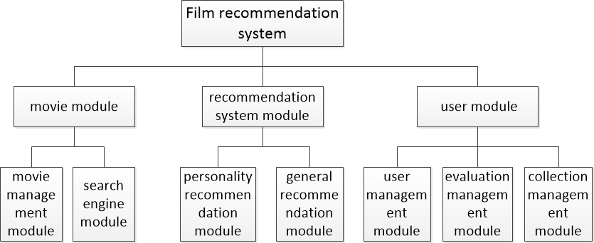

Figure 1 project module design

2.3 assumptions and constraints

The assumptions include: the user is not satisfied with the function of the product, the user is difficult to operate and use, the project development cannot be delivered on time, the product can not adapt to various operating environment and platform well, and the developers have an unexpected situation.

The constraints include: the submission of the target deliverables and the product completion degree shall be generally in line with the design objectives within the target construction period.

The solutions include: the person in charge communicates with the developers on time and communicate with the progress, designs the alternative personnel plan in case of emergency in advance, and tests in time in each step of design.

**3 Project personnel arrangement**

3.1 Division of personnel

|  |  |  |
| --- | --- | --- |
| Name | Role | Job Description |
| Xiao pin | Chief development engineer | Product planning and design, product review, demand feasibility assessment, development architecture, deployment online, development optimization |
| Wang Ziqing | Development  Engineer  Test Engineer | Make development plan, WBS task decomposition, project planning, delivery, review, test plan, test case writing, test plan, function test |
| Deng Panpan | Ui designer and Development Engineer | Requirements research, business function sorting, prototype design, requirements confirmation, UI design, interface protocol design, coding specification, development, bug handling |

Table 1 Division of personnel

3.2 work arrangement

Within the team, the team leader will be rotated according to the working week, so as to improve the team cooperation consciousness and project management experience of each member.

Personnel have their own main responsibility modules.

Xiao pin will be responsible for algorithm research, main code writing and discussion, as well as part of his own document writing.

Wang Ziqing is responsible for writing the main code, participating in the discussion of algorithm and interface, and writing some documents.

Deng Panpan is responsible for the design and writing of the interface, the discussion of the code and algorithm, and the writing of some documents.

In case of emergency, such as: the project leader is unable to complete his work, all team members will make a decision about the project after discussion.

**4 Project implementation plan**

4.1 Project schedule

The project construction period is scheduled to start on April 12, 2021 and end on June 11, 2021. The code or document to be delivered by each time node must be completed on time in the target cycle, and a deliverable product shall be completed before the project deadline.

4.2 WBS

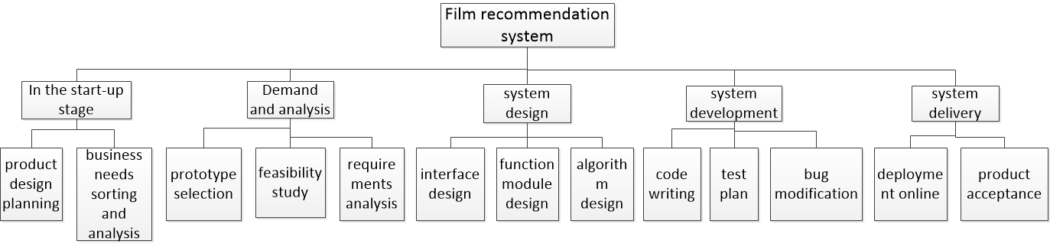

Figure 2 WBS diagram

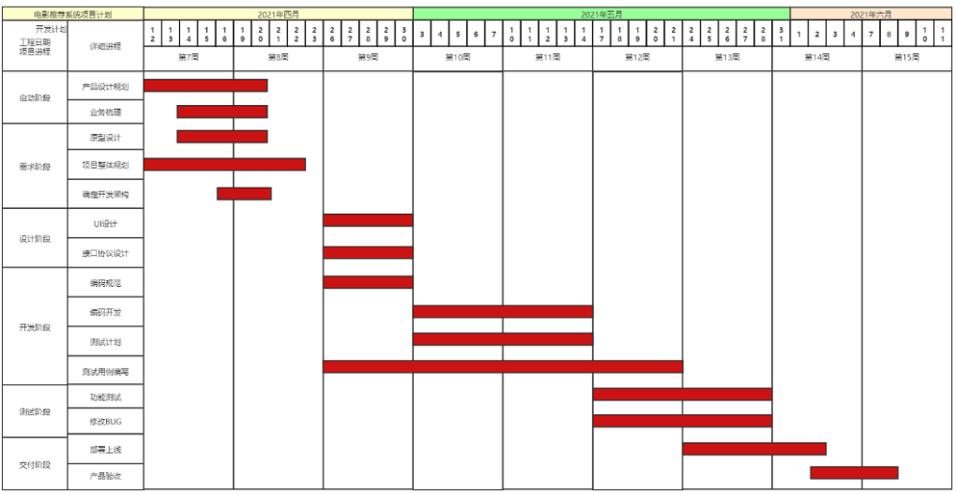4.3 Gantt chart

Figure 3 Gantt chart

图片链接：<https://www.processon.com/view/link/60816dca1e08534b2ef30bbb>

4.4 Milestones and deliveries

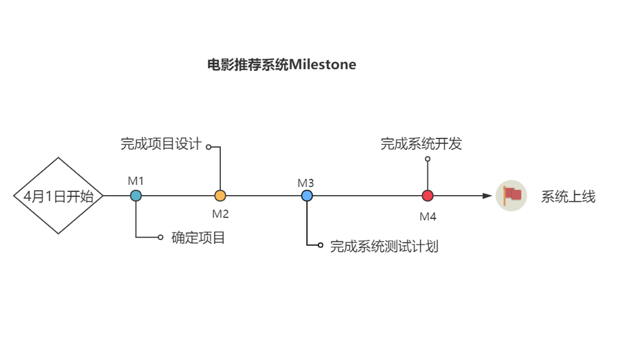

Figure 4 milestone chart

|  |  |  |
| --- | --- | --- |
| Milestone | delivery | date |
| determines project scope | **project plan** | **2021.04.22** |
| Complete project design | **Detailed system design，test cases** | **2021.04.30** |
| Complete the system test plan | **test plans，test reports** | **2021.05.14** |
| Complete the system development | **complete system development** | **2021.05.28** |
| System online | **Running website project** | **2021.06.08** |

Table 2 milestone delivery list